Samuel Ogunfunmi

Use variables abstraction to make your programs more general-purpose

9/7/20

**Problem 1)**

**1. Algorithm (Solution Plan for the Problem):**

1. Find the value of the first integer. Store integer.
2. Find the value of the second integer. Store integer.
3. Find the value of the third integer. Store integer
4. Create Variables for sum and the total number of integers.
5. Find average by dividing the sum of integers by the number of integers
6. Display Average to the user

**2. Program Source Code (copy and paste from IDE):**

def main(): #include this line in every program

int_1 = 9 #Hard code the first integer

int_2 = 7 #Hard code the second integer.

int_3 = 15 #Hard code the third integer

int_sum = int_1 + int_2 + int_3 #Create Variables for sum of numbers

number_of_int = 3 #total number of integers

Average = (int_sum / 3) #Average formula

print("The average is ", Average) #Display the average to the user.

main() #Call to main() is also required at the end of every program

**3. Program Output Screenshots/Screen Print(s) and/or Error Messages:**



**Problem 2)**

**1. Algorithm (Solution Plan for the Problem):**

1. Create Variable for name
2. Ask the user to Input their name
3. Save their input as a variable.
4. Greet the user with a message.
5. Ask the user to input how many hours they worked.
6. Ask the user to input the rate at which they are paid.
7. Display the number of hours worked
8. Display the hourly rate they are paid.
9. Calculate gross pay by multiplying hours worked and rate together.
10. Display the total gross pay amount

**2. Program Source Code (copy and paste from IDE):**

def main(): #include this line in every program

name = input("What's your name? ") #Asks user for their name

print ("Hello ", name)#Greeting

hours = input ("Enter Hours: ") #Ask for hours worked

h = float(hours)

rate = input ("Enter Rate: ") #Ask for rate

r = float(rate)

grosspay = h * r #Calculate total gross pay

print ("Pay: ", grosspay) #Display gross pay total

main()

**3. Program Output Screenshots/Screen Print(s) and/or Error Messages:**

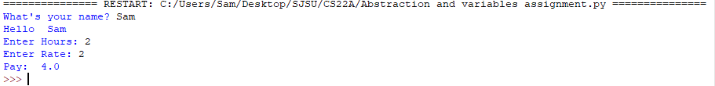

**Problem 3)**

**1. Algorithm (Solution Plan for the Problem):**

1. Ask the user to input the temperature in Celcius.
2. Save this input as a variable.
3. Create variable Fahrenheit Conversion
4. Convert Celcius to Fahrenheit using the formula
5. Use the conversion formula : ((Temp_C * 9 / 5) +32))
6. Display converted temperature to the user.

**2. Program Source Code (copy and paste from IDE):**

def main(): #include this line in every program

Celsius = input("What is the temperature in Celsius? ")#Input from the user

C = float(Celsius)

Fahrenheit = ((C * 9/5) +32)#Converts C to F

print ("This temperature in Fahrenheit is ", Fahrenheit, " degrees") #Prints converted temperature

main()

**3. Program Output Screenshots/Screen Print(s) and/or Error Messages:**

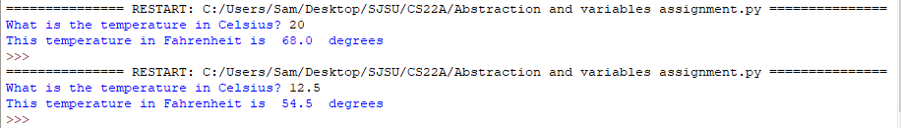

**Conclusion/What you learned writing this program and what problems you encountered.**

I learned how to use abstraction correctly, convert variables, and use formulas in this program. I encountered a problem converting the variable to float but realized that I needed to use another variable to convert it to. An example is using C for converting Celsius to a float instead of keeping it as Celsius = float(Celsius).